**CATW**

[CATW](https://p01-dxc.sapnet.dxccorp.net/hps-ic) is a tool used by all DXC employees to track their labor effort on a daily basis.

Based on information filled DXC is billing their customers every month for the services provided. Before you start, ask your manager, if your account is setup or you need to request a new account.

1. How to access CATW?

Follow the [link](https://p01-dxc.sapnet.dxccorp.net/hps-ic) and log on by using your Digital Badge credentials (if you have enrolled for one), or, use your email and domain password.

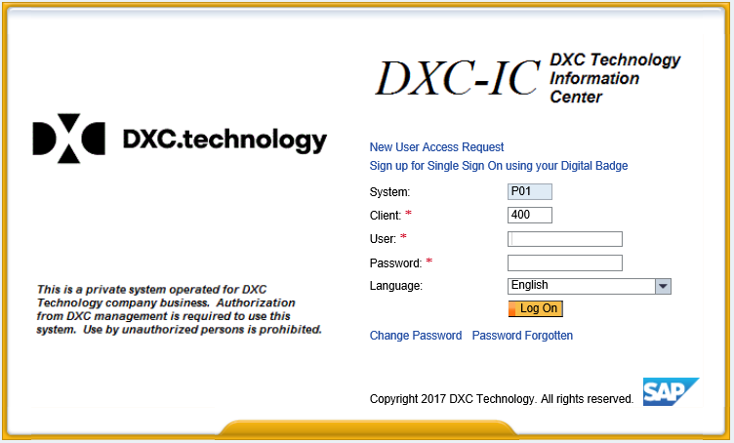

1. If you are a new user you will have to request an account for CATW tool:

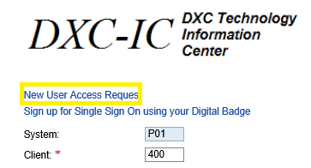

1. Fill in your employee ID (if you do not know it, approach your TL or manager):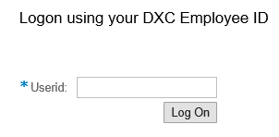
2. Click on Access Request Creation:

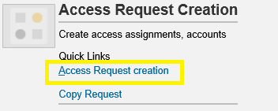

1. Fill business justification (example: new employee of DXC, DTC Sofia – Digital Marketing and Sales Specialist), select “New Account” and the desired completion date for your request:

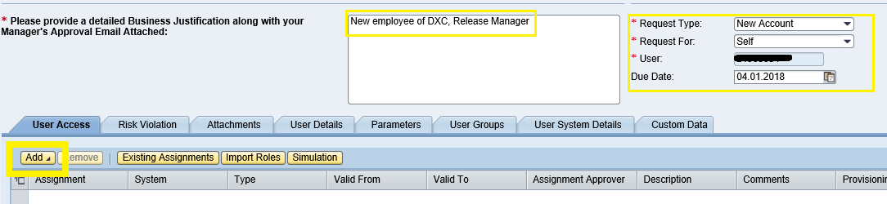

Add System and Role:

“System is P01 – EMEA Production”

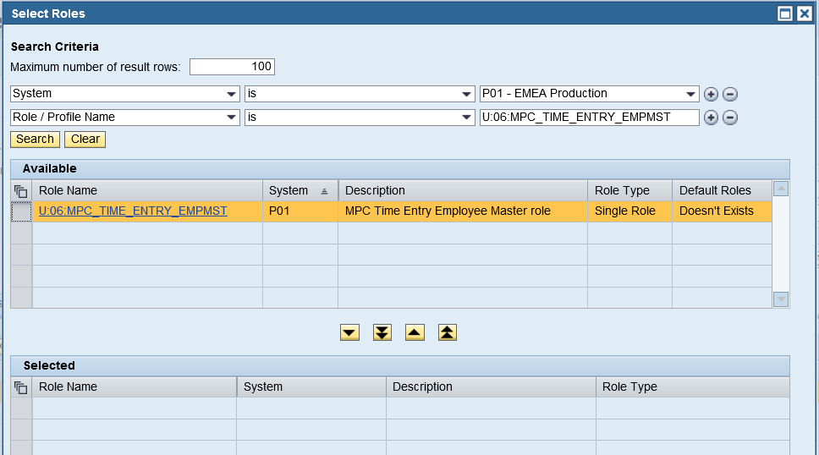 “Role / Profile Name is U:06:MPC_TIME_ENTRY_EMPMST”, as bellow:

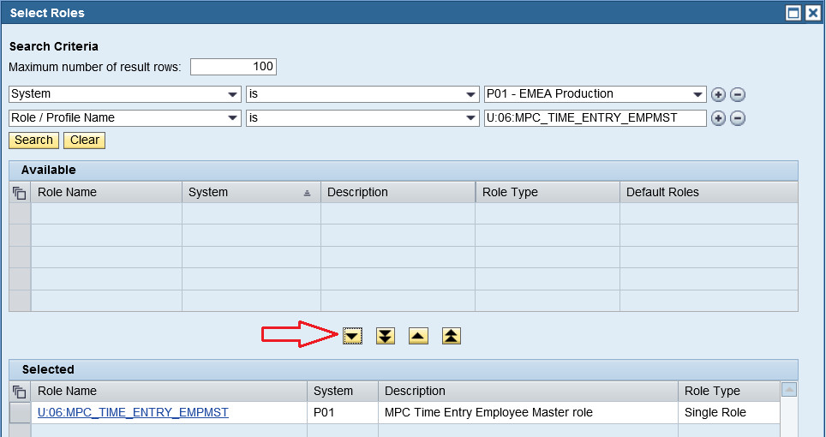Then, select the role in “Available” area, click the arrow pointing down and the role will appear in “Selected” area, as shown below and then click “Ok”.

Next, click on “Add Comments” – the comment is free text, you can state that you need this role in order to track your day-to-day activities in CATW.

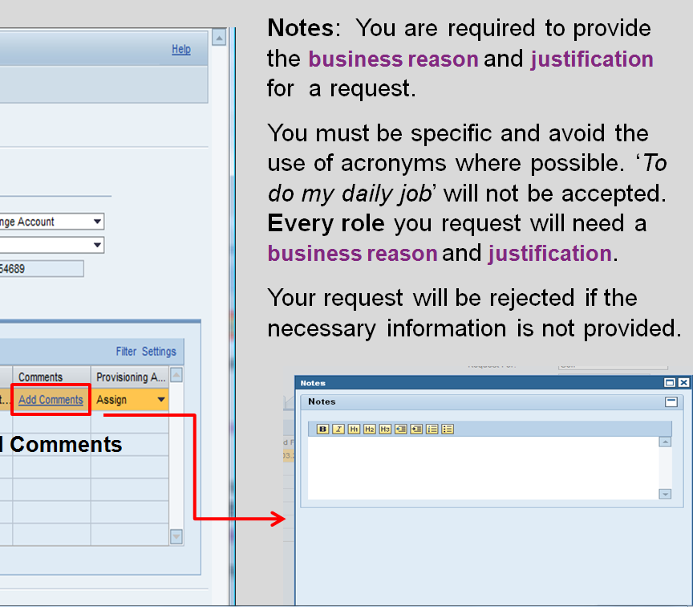

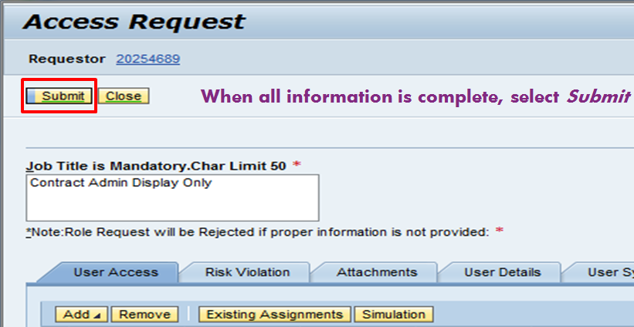The last step is to click on “Submit” button

And now you wait for the request to get implemented.

If your access has already been setup, but you can’t log in, your account needs to be unlocked and validity should be extended (see below).

Here are the steps you need to follow:

Please first log a ticket to BISD team to unlock your account.

1. Log in to the [**Service Central**](https://servicecentral.itcs.entsvcs.net/gbshub/gbshome.aspx?l1Name=BISD%20and%20Finance%20Support&l2Name=Security%20and%20Authorizations&l2=186&l1=62) with your digital badge
2. Change your default language to **English**
3. Select the support area - **BISD and Finance Support** - on Service Central main page
4. Click the drop down and select the **support capability area** (Choose “security and authorization”)
5. On the next screen – **Browse by Service** – select the system, tool or process in which your issue persists (choose “COMPASS Security”)
6. Expand the dropdown list by clicking “**More”** and choose one issue type that applies to your query (Choose “Security issue”)
7. Click on the **Submit a Case** button which directs you to the next screen
8. Your service details are populated, your query/issue details must be entered as well as all mandatory fields must be filled in
9. Click **Submit**

* Where it says “digital badge”, that basically means your HPE account. This is likely to change with the DXC migration.

Please be noted that when you log in GRC or CATW, please use your 8-digit employee number NNNNNNNN, rather than your global ID.

Once this request has been completed, follow the steps in the following screenshots, which shows you how to reset your password.

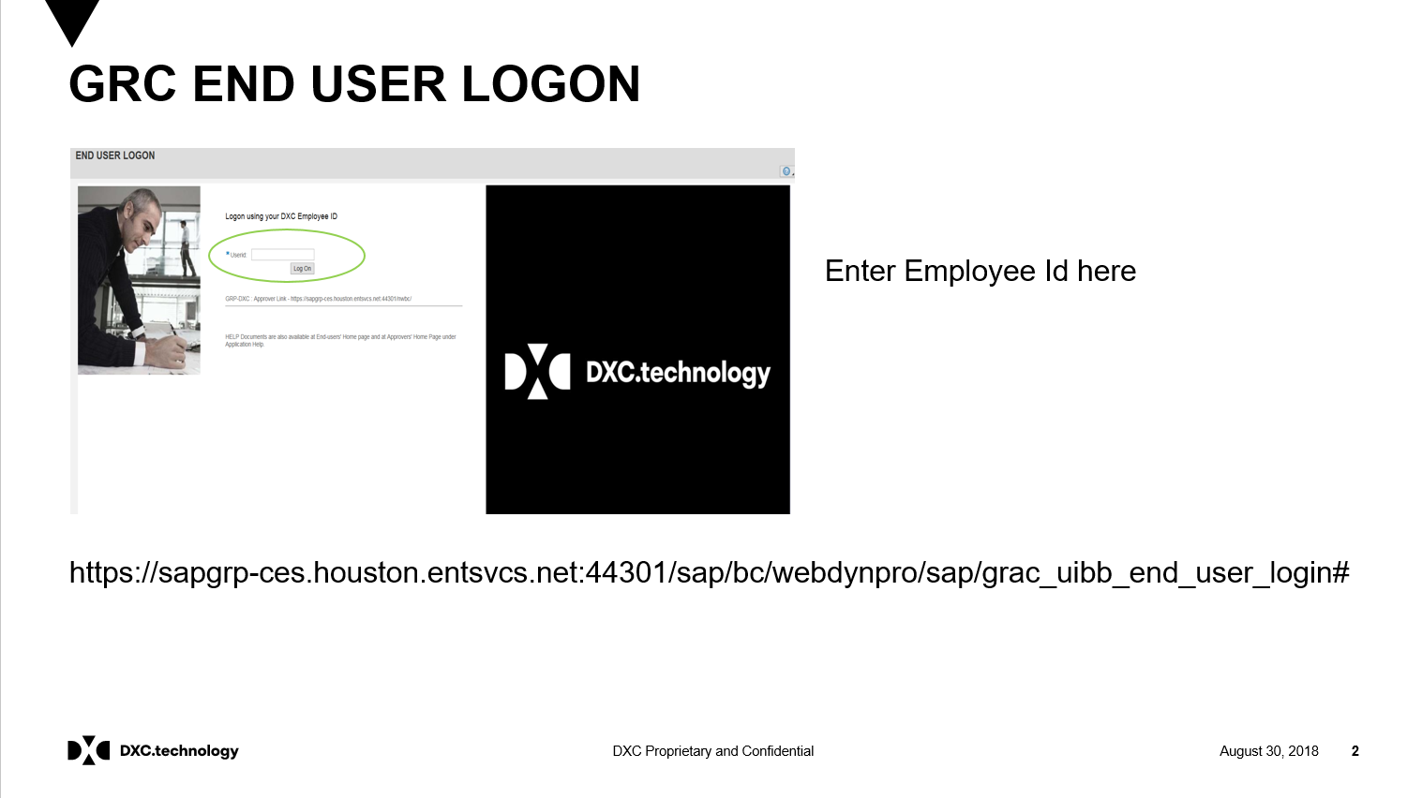

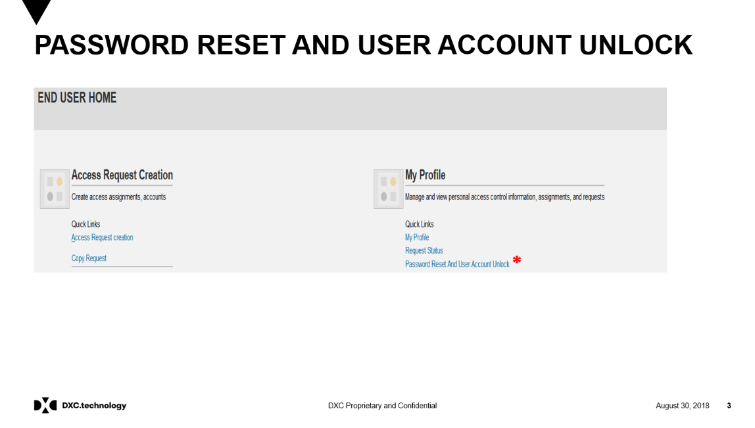

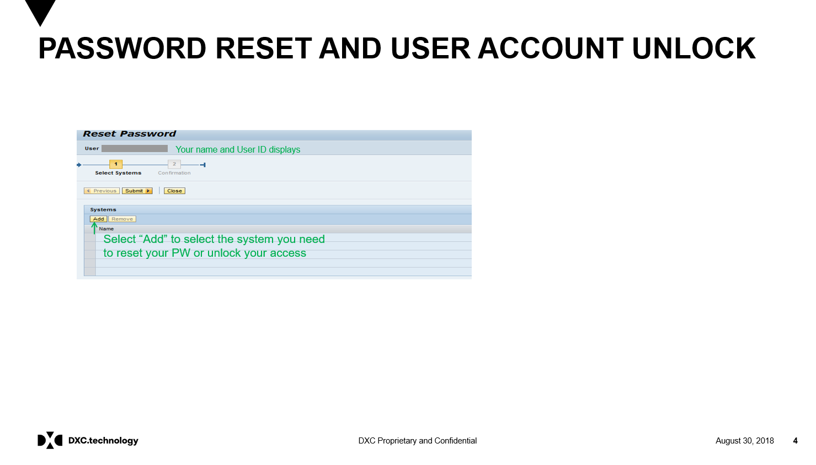

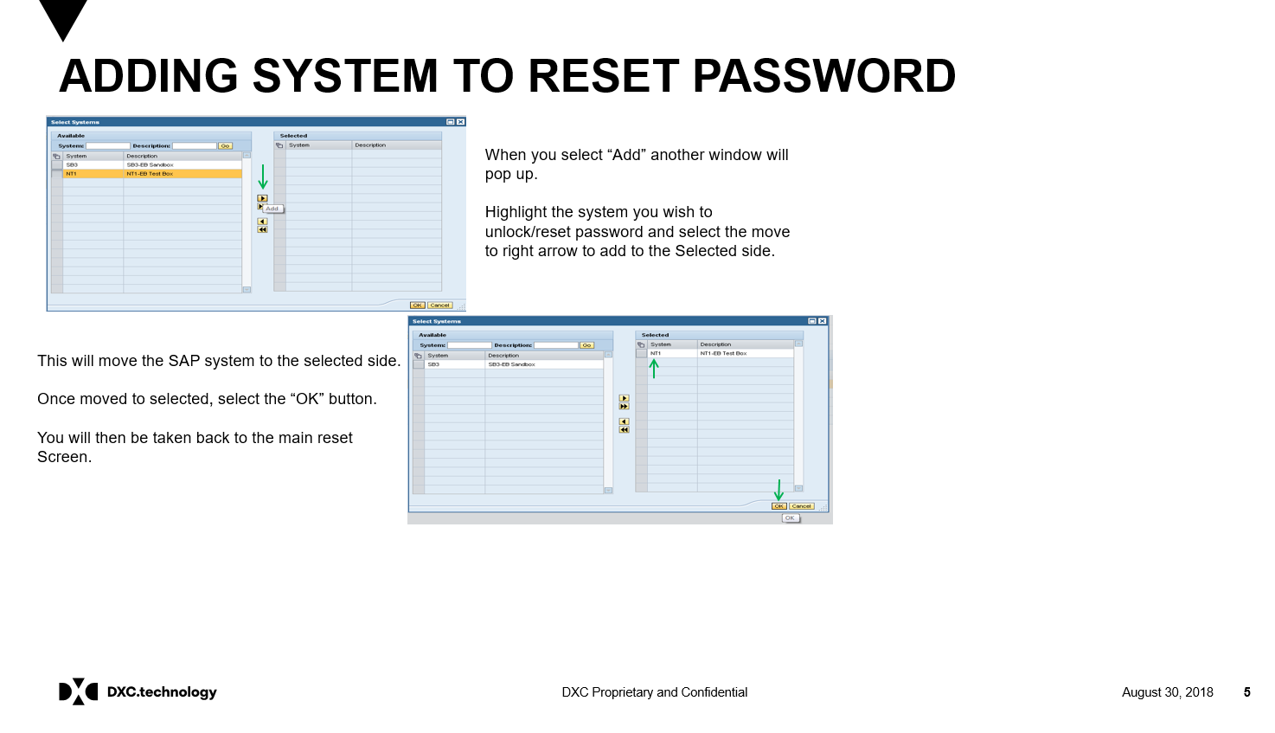

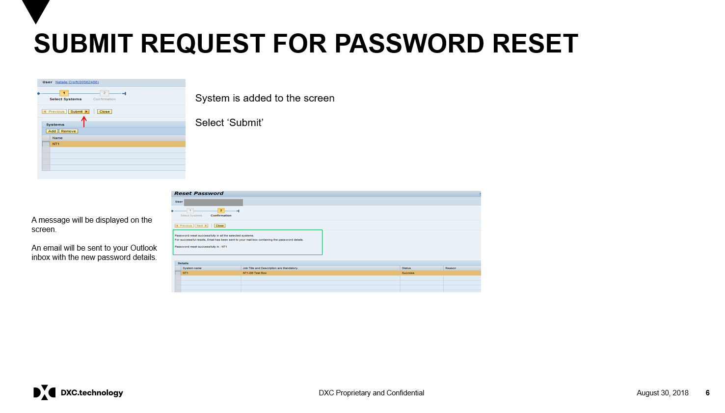

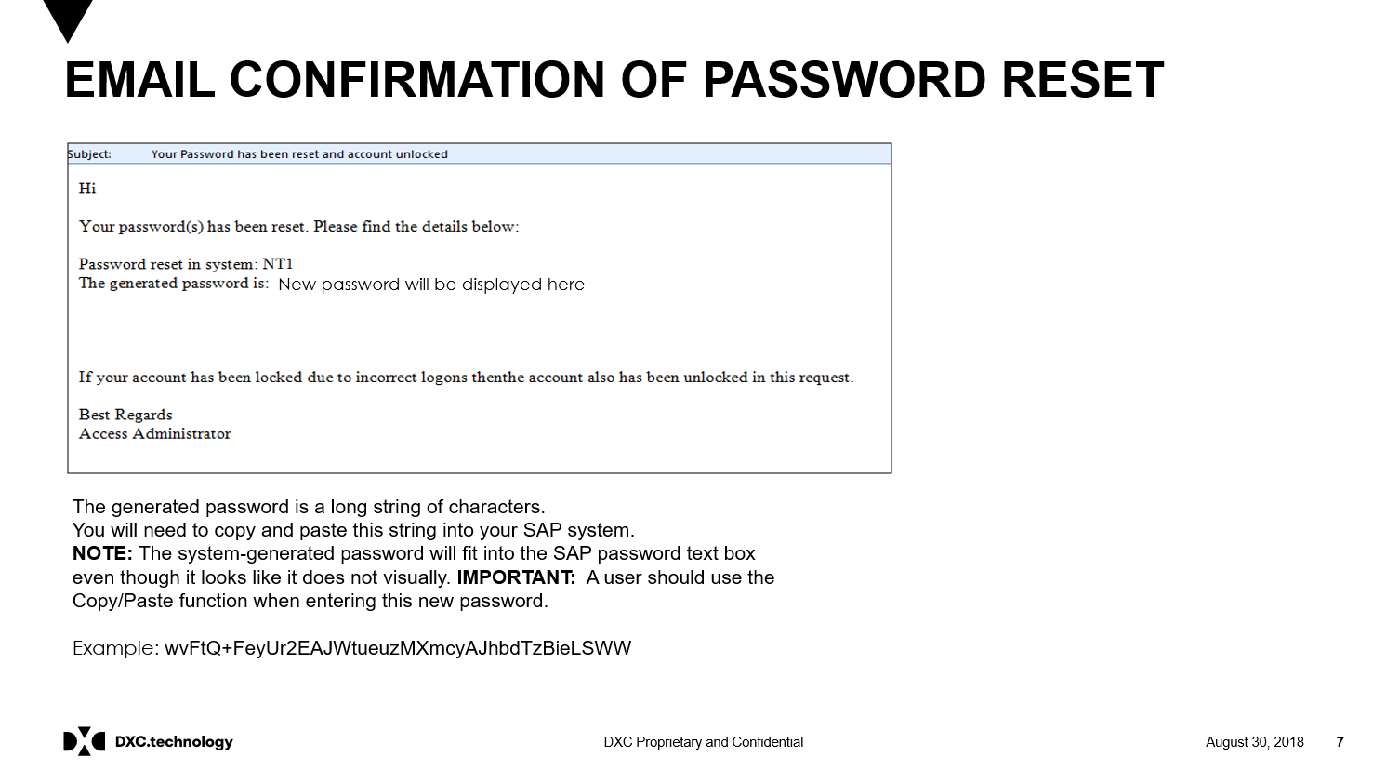

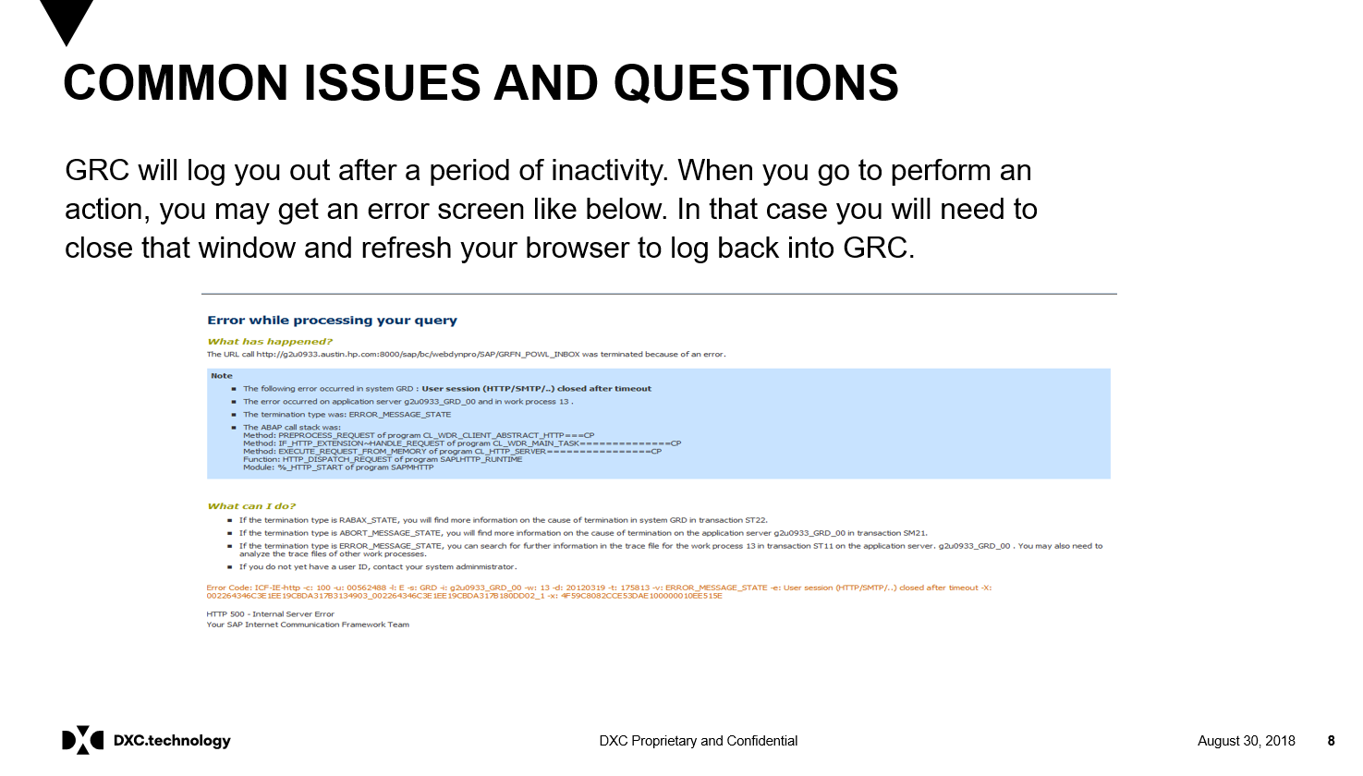

Please note it is of high importance to track your effort on a daily basis. Otherwise DXC will not be able to invoice the customers for the services we have provided!

CATW compliance is one of your personal targets and affects your performance. Please make sure your weekly tracking is compliant every Friday, before 10 CET AM.